Janis Gonzalez

WEB 420 RESTful APIs

Assignment 2.2 Composer API Interface

March 26,2023

Bellevue University

**PART 1:**

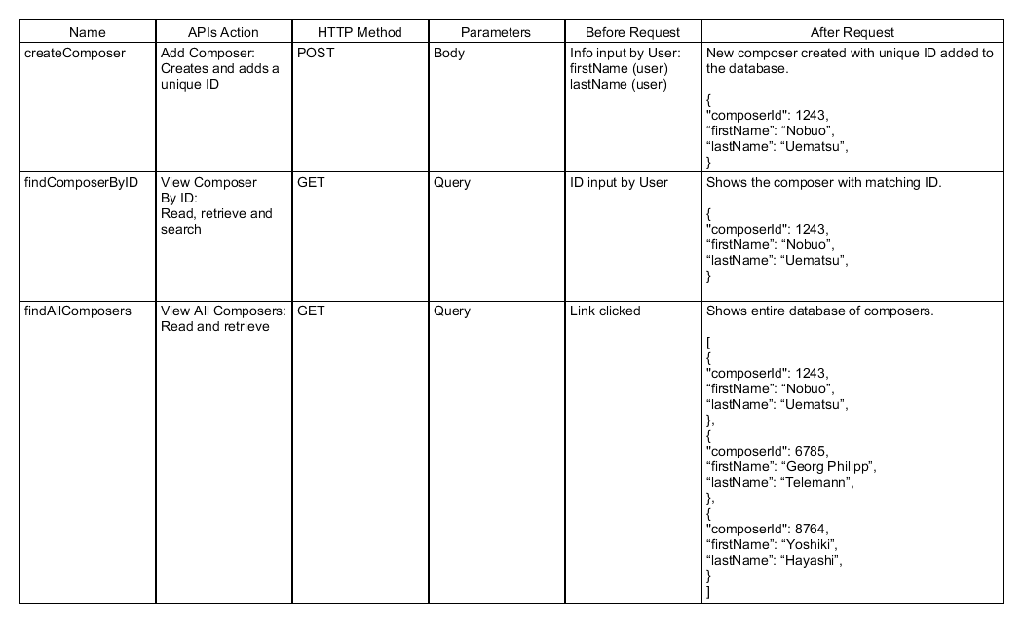

**PART 2:**

